**Cycles Process**

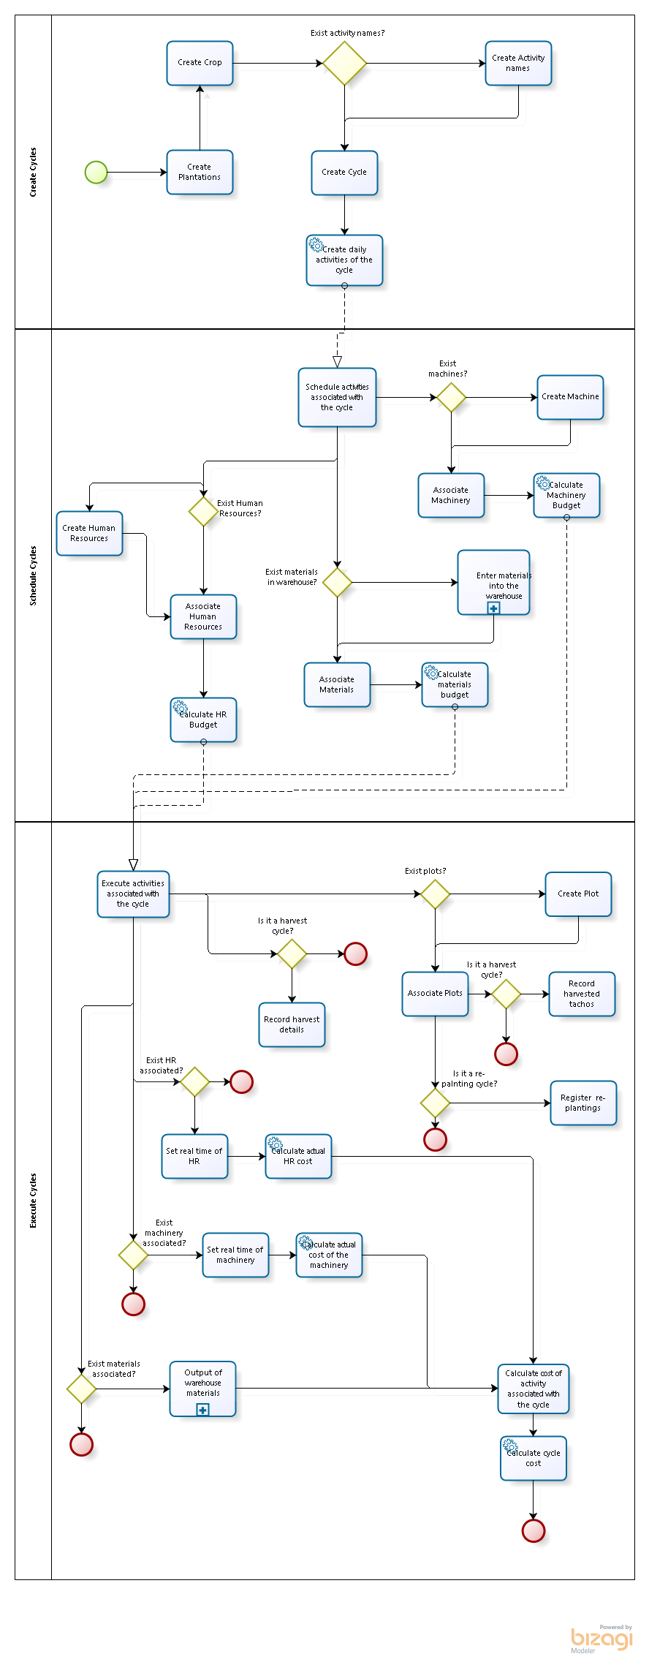

**Subprocess: Enter materials into the warehouse**

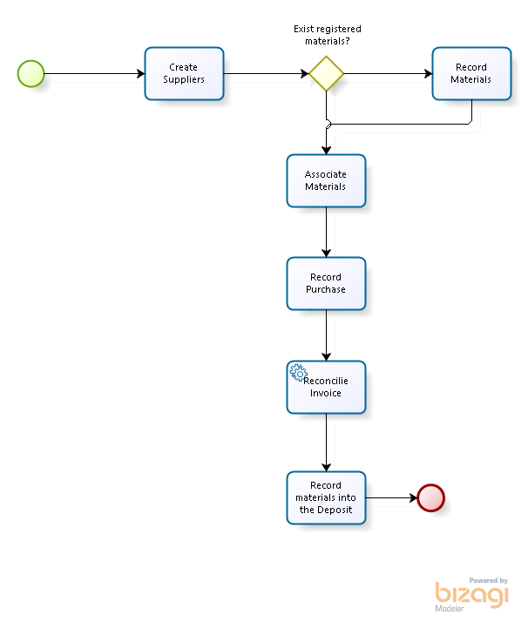

**Subprocess: Output of warehouse materials**

